**Class Assignment**

1. A. Suppose there are 3 instances of resource tape drives, 3 instances of resource graphics and 2 instances of resource printers. Process 1 holds one unit of resources of both graphics and printers and is waiting for one unit of tape drives. Process 2 holds two units of tape drives and -0waiting one unit of graphics. Process 3 holds one unit of graphics and one unit of printer. Process 4 holds one unit of tape drive and one unit of graphics and waiting for one unit of printer. Draw the resource allocation graph for the above scenario. Is the system in a deadlocked state? Explain.
2. Draw a wait-for graph from following resource allocation graph. Is there any deadlock? Why or why not explain.

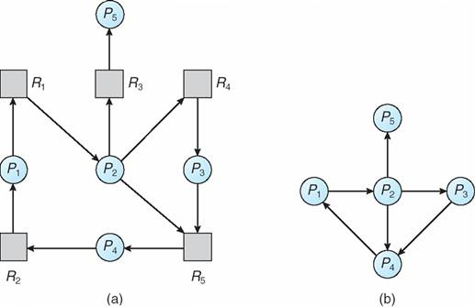

1. Draw a wait-for graph from following resource allocation graph. Is there any deadlock? Why or why not explain.

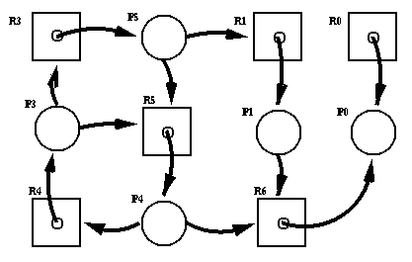

1. Identify the critical section of the following problem: Suppose, your teacher is checking lab assignment in a class of 30 students. S/he is checking one by one. S/he is also marking individually but s/he can show the marks to all students at the same time. Identify critical section(s) for the case.